**USE OF BUILDING INFORMATION MODELING (BIM) TO PLAN ENERGY-EFFICIENT APARTMENT BUILDINGS**

**Balasuriya P.A.G.D.**

*Undergraduate, Department of Civil Engineering, University of Moratuwa, Sri Lanka*

**Dr. Piyaruwan Perera, Dr. Kasun Kariyawasam, Prof. (Mrs.) Chintha Jayasinghe**

*Department of Civil Engineering, University of Moratuwa, Sri Lankan*

**Abstract:** Extensive energy use and the resultant greenhouse gas (GHG) emissions in multi-story multi-family residential buildings are rapidly increasing due to population growth and improvements in quality of living. The building sector accounts for 40% of global energy consumption and 36% of GHG emissions. A significant amount of research studies are focused on energy-efficient building planning, cost-effective building planning, and reducing the GHG emission of buildings. In most of these studies, authors have identified the importance of the life cycle thinking approach for the design phase of the buildings. However, there is a lack of research on automated BIM-based software that could estimate the optimum building material and assembly combination as per the requirements of the client. This research aims to develop an optimum building material/assembly selection framework using the life cycle thinking approach and develop the selection framework as an automated software tool. The optimum material/assembly selection is created by quantitative analysis of the life cycle components of energy, cost, and carbon footprint. Further analysis was carried out to identify the optimum building orientation, which leads to further improvement in carbon, cost, and energy efficiency. Finally, an automated tool was developed with the capabilities to analyse BIM models of multi-story multi-family residential buildings and suggest the optimum material/assembly and optimum orientation as per the user requirements. The use of this developed tool will provide long-term solutions for the current economic and energy crisis in Sri Lanka by guiding how to reduce the cost and energy consumption of buildings while reducing GHG emissions.

**Keywords:** BIM; Building planning; Material selection; Automation; Sustainable

1. **Introduction**

Building energy consumption and resultant greenhouse gas (GHG) emissions are key concerns in the world. Matsuo, Yanagisawa and Yamashita (2013) emphasized that the energy consumption in Asia will increase 1.8 times within the next twenty-five years. Even though there are many energy-consuming sectors, the building sector consumes 40% of energy from the national energy consumption and emits 36% of GHG emissions (Amasyali & El-Gohary, 2018).

Literature reveals that the use of energy-efficient methods and upgrades used for buildings will reduce the energy demand of buildings (Pan et al., 2010). Apart from the energy efficiency, the cost and quality of the building should be taken into account when deciding the optimum solution for planning an energy-efficient building (Thapothiny et al., 2017). Hence enhancing the energy efficiency of apartment buildings are not straightforward, and needs a scientific approach and proper planning mechanism to incorporate budget restrictions and achieve the required design qualities.

Many researchers have conducted research on energy-efficient buildings and cost-effective buildings without integration between them. But there is a gap in knowledge adopting those methods for Sri Lankan scenarios and the interoperability between cost-effective and energy-efficient building designs.

Therefore, there is a need for a planning approach to design energy-efficient and cost-effective multi-story multi-family residential buildings using Building Information Modeling (BIM) (Rodrigues et al., 2020).

This study develops an automated software tool as a planning approach to enhance the energy efficiency, cost and carbon emission of multi-story multi-family residential buildings using a BIM-based model. This would lead to obtaining energy-efficient, cost and quality-optimized building design at the planning stage.

This study aimed to develop a practically applicable tool, that can be used to plan energy-efficient and cost-effective apartment buildings. The aim was achieved by the following objectives.

* Developing an analyzing procedure to calculate life cycle energy, life cycle cost and life cycle carbon emission considering all the material and system combinations of a selected building
* Assessing the results of the previous objective using the MCDM approach to determine the optimum material combination and the optimum building orientation
* Developing the above objectives as an automated tool to select optimal upgrades for multi-story multi-family residential buildings

1. **Methodology**

Three phases are implemented in this methodology up to the automated software tool design process. The first phase and the second are the decision-making process and phase the third phase is the automated tool development. The illustrated conceptual framework in Figure 1 and Figure 2 are used as the research methodology.

Literature Review

Selection of Case Study BIM Model

Expert Consultation

Op. Cost

Embedded Energy

Op. Energy

Retest the model with a different material combination

Initial Stage

Operational Stage

Capital Cost

Phase 1

Embedded Carbon

Op. Carbon

**Phase 1**: Phase 1 includes the literature review, expert consultation, case study BIM model selection and the quantitative analysis part. Every different material and assembly combination is tested for energy, cost and carbon performance.

Figure 1: Phase 1 - Initial and operational analysis

**Phase 2**: The ranking process of the combinations is included in phase 2. “Analytic Hierarchy Process” (AHP) and “Technique for Order Preference by Similarity to Ideal Solution” (TOPSIS) methods are used to rank the combinations for 3 different scenarios.

Simulation Results

AHP

Building orientation analysis for optimum combination for the 3 scenarios

Pro Economic

TOPSIS

Phase 2

AHP

Sustainable friendly

TOPSIS

AHP

Net - zero

TOPSIS

Figure 2: Optimum materials and orientation selection

**Phase 3**: Phase 3 is the development of the automated software tool, which can automate all the analysis and ranking procedures in phase 1 and phase 2. “Revit”, “Dynamo”, “Excel” and “Visual Basic for Applications” (VBA) is used for the development of the tool.

1. **Analysis and Results**

The quantitative analysis was done considering only the building envelope (wall, window, door, floor, roof). The equations and the procedure followed are mentioned in the below sections.

**3.1 Embodied Energy Calculation**

Embodied energy is calculated for the 5 building envelope elements by the equation mentioned below. Wall, window, door, floor and roof.

(1)

$$Embodied energy \left(MJ\right)= Embodied energy rate \left({MJ}/{m^{2}}\right)* Total area ofeach element(m^{2})$$

**3.2 Life Cycle Operational Energy Calculation**

Only the operational energy consumption by the A/C systems is assessed in the study. The air conditioning energy demand for apartment buildings is assessed by the ASHRAE “Cooling and Heating Load Calculation Manual” The equations used in the analysis are as follows.

Heat gain through the external roof,

(3)

(2)

$$q=U × A × {CLTD}_{Corrected}$$

$${CLTD}_{corrected}=\left[\left(CLTD + LM\right)×K+\left(78- T_{R}\right)+\left(T_{o}-85\right)\right]×f$$

Heat gain through external walls,

(5)

(4)

$$q=U × A × {CLTD}_{Corrected}$$

$${CLTD}_{corrected}=\left(CLTD + LM\right)×K+\left(78- T_{R}\right)+\left(T_{o}-85\right)$$

Heat gain through doors, windows and floor – (conduction),

(6)

$$q=\left(UA\right)× ∆t$$

Heat gain through windows – (solar radiation),

(7)

$$q=A×SC× {SHGF}_{max} ×CLF$$

Heat gain by ventilation – sensible and latent,

(9)

(8)

$$q_{s}=1.10×\left(Δt\right)×scfm$$

$$q_{l}=4840×\left(ΔW\right)×scfm$$

Heat gain by lighting,

(10)

$$q= DF×q_{i}×F_{u}×F_{s}×CLF$$

Heat gain by occupants – sensible and latent,

(12)

(11)

$$q={DF×q}_{s}×No. of people×CLF$$

$$q={DF×q}_{l}×No. of people$$

The number of required A/C systems is calculated by the following equation,

(13)

$$Number of air conditioning units=\frac{Peak cooling load (kW)}{Capacity of one AC system (kW)}$$

**3.3 Cost Calculation**

The capital cost of walls, windows, doors, floors and roofs is calculated by the following equation.

(14)

$$Initial cost \left(LKR\right)= material and construction rate \left({LKR}/{m^{2}}\right)* Total area of each element(m^{2})$$

The operational cost of A/C systems is calculated by the following equation,

(15)

$$Operational cost \left(LKR\right)=Cooling load per year \left(kWh/year\right)×Building life cycle period \left(year\right)×Average unit energy cost (LKR/kWh)$$

The number of A/C system replacement and the replacement cost is calculated by the following equation.

(17)

(16)

$$HVAC system replacements=\frac{Life expectancy of building (years)}{Life expectancy of AC systems (years)}-1$$

$$AC system replacement cost \left(LKR\right)=No. of replacements×Unit price of AC system (LKR)$$

**3.4 Carbon Footprint Calculation**

The embodied carbon of walls, windows, doors, floor and roof is calculated by the following equation.

(18)

$$Embodied carbon \left(kg\right)= Embodied carbon per sq.meter \left({kg}/{m^{2}}\right)* Total area of each element(m^{2})$$

The operational carbon emission by A/C systems is calculated by the following equation.

(19)

$$Operational carbon emission \left(kg\right)=Cooling load per year \left(kWh/year\right)×Building life cycle period \left(year\right)×CO_{2} emission per unit energy (kg/kWh)$$

**3.5 Optimum Orientation of Building**

The calculations, mentioned in previous chapters are done while the building is oriented in a specific direction. The same calculation process is done while rotating the building one degree by one degree in the clockwise direction. After analyzing all 360 degrees, the optimum orientation of the building is identified.

**3.6 Ranking Method**

The ranking process is started after the calculations of energy, cost and carbon footprint. In this study, both AHP and TOPSIS methods are used for the decision-making process.

**3.6.1 Analytic Hierarchy Process (AHP)**

The weightages for the cost, energy and cost are derived by the AHP method for the following 3 scenarios separately (Pro-economic scenario, sustainable friendly scenario, net-zero scenario).

**3.6.2 TOPSIS**

The “Technique for Order of Preference by Similarity to Ideal Solution” (TOPSIS) method is used for ranking the combinations with the use of weightages taken from the AHP method.

**3.7 Scenario Analysis**

Scenario analysis is done in this study to generalize the concept and to increase the usability of this automated software tool. The following 3 scenarios are considered in the study.

* Pro-economic scenario
* Sustainable friendly scenario
* Net-zero scenario

Optimum material/assembly and the optimum orientation angle are determined independently for each scenario.

**Pro-economic scenario –** Total energy, total cost and total carbon footprint are used as the attributes for the “Pro-economic” scenario. A high weightage is given for the total cost attribute, to select a more economical solution as the optimum solution.

**Sustainable friendly scenario -** Total energy, total cost and total carbon footprint are used as the attributes for the “Sustainable friendly” scenario. A high weightage is given for the total energy and carbon component, to select a more sustainable friendly solution as the optimum solution.

**Net-zero scenario –** Total energy, system cost, capital cost and embodied carbon are used as the attributes for the “Net-zero” scenario. A net-zero building should be high energy efficient to reduce the energy demand. Reduced energy demand will save the cost of energy generation and maintenance. Therefore, a higher weightage is given to the “total energy” attribute and “embodied carbon”.

**3.8 Automated Software Tool Designing Process**

The automated tool is developed using the “Revit”, “Dynamo”, “Excel” and “VBA”. The previously mentioned equations and calculation procedure is automated and the decision-making process is also implemented.

**3.8.1 BIM Model Data Extraction**

“Revit” and “Dynamo” software are used for the extraction of building data. “Revit” is used for the BIM model creation and “Dynamo” is used for the data extraction process. Only the building geometric data and details of building elements are extracted from the BIM model.

A simple overview of the data extraction Dynamo code is shown in Figure 3.

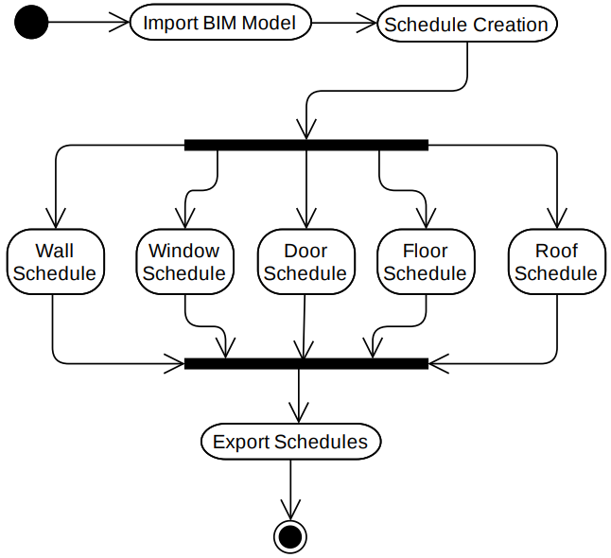

Figure 3: BIM model data extraction

**3.8.2 Data Cleaning and Transformation**

The exported data is then cleaned and transformed to use as the inputs for the calculations. The “Excel” software and “VBA” is used for this process and the remaining process. The data type conversion, calculating summation, calculating averages, data filtering and direction calculation process is done in this step, before the analysis process.

**3.8.3 Energy Simulation**

After the data transformation process, the energy simulation process is started. Calculations mentioned in the previous chapter are used for the simulation. The energy simulation is done for every combination of materials. The same analysis process is done hour by hour for 17 hours (the A/C is used 17 hours per day). After 17 iterations, the cooling load for a day can be calculated. Cooling load requirement changes throughout the year due to climatic changes. Therefore, the same calculation process is done month by month for 12 months.

**3.8.4 Cost Calculation**

The cost is calculated simultaneously, with the energy simulation. The previously mentioned cost calculation equations are used in the cost calculation process and a simple overview of the cost calculation VBA code is shown in Figure 4.

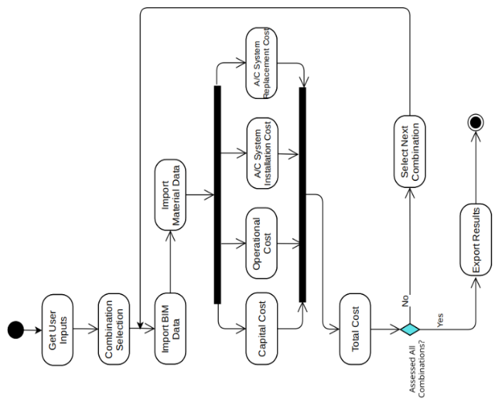

Figure 4: VBA cost calculation process

**3.8.5 Carbon Footprint Calculation**

The carbon footprint is calculated simultaneously, with the energy simulation. The previously mentioned carbon footprint calculation equations are used in the calculation process. The process is automated with the VBA coding.

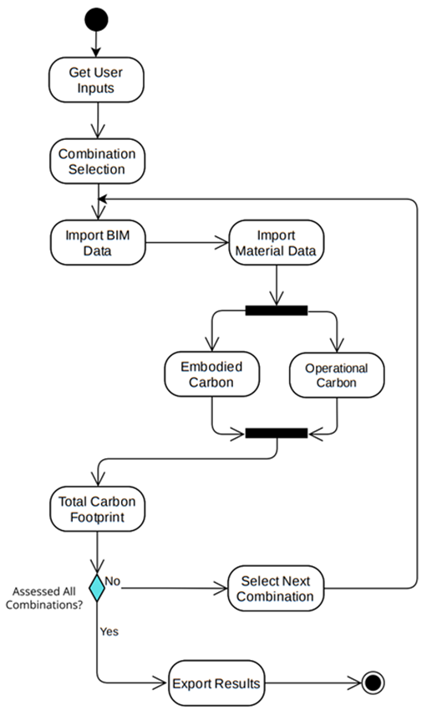

Figure 5: VBA carbon footprint simulation

**3.8.6 Orientation Analysis**

The orientation analysis is done after the selection of the optimum material/assembly combination. Then the optimum materials/assembly are assigned for the 3 scenarios independently. After that, the orientation analysis was also done separately for the 3 scenarios.

**3.9 Case Study**

The following Revit BIM model in Figure 6 is selected as the case study, which fulfils the selection criteria.

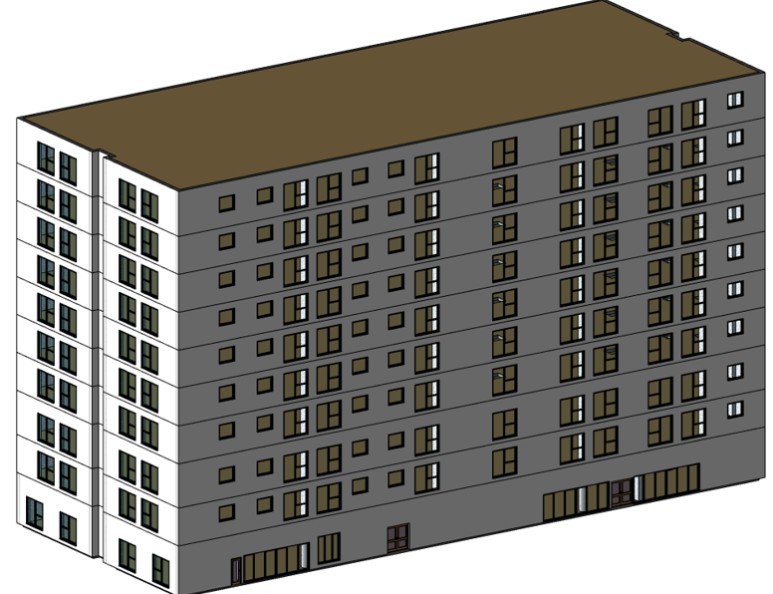

Figure 6: Revit case study BIM model

Details of the BIM model,

* Floors of the building - 10
* Residential units - 126
* Total floor area - 11,076.6 m2

**3.10 Results**

The case study is analyzed for all the calculations mentioned above, using the automated tool. Energy, cost and carbon footprint values are generated for every material combination independently. A sample result for a selected material combination is mentioned in Table 1.

Table 1: Results of a selected material combination

|  |  |
| --- | --- |
| Maximum Load (kWh/hr) | 410.7162609 |
| No. AC Systems | 30 |
| Cooling Load (kWh/year) | 1366100.598 |
| Embodied Energy (MJ) | 47359.63573 |
| LC Operational Energy (MJ) | 245898107.6 |
| Capital Cost (LKR) | 6332337.659 |
| Operational Cost (LKR) | 2049150896 |
| System Cost (LKR) | 112386000 |
| Embodied Carbon (Metric T) | 25.9845251 |
| Operational Carbon (Metric T) | 20423.20393 |
| Total Energy (MJ) | 245945467.2 |
| Total Cost (LKR Million) | 2167.869234 |
| Total Carbon (Metric T) | 20449.18846 |

The same type of report is generated for all the material combinations. The following charts are also generated by the automated tool,

* Total energy (MJ) variation
* Total cost (Millions) variation
* Total carbon footprint (T) variation
* Performance score variation for 3 scenarios
* Orientation analysis for 3 scenarios

Further, the optimum material combination is suggested for 3 scenarios separately.

**3.11 Validation**

The above-generated results are validated by manual calculation and by software simulation also. The cooling load calculation is validated by the “Revit Cooling and heating load calculation” option for a selected material combination. The orientation analysis is validated by the “Autodesk Insight” web solution. Other results are validated by manual calculation. Table 2 shows a summary of validation.

Table 2: Summary of validation

|  |  |
| --- | --- |
| Calculation | Accuracy |
| Embodied energy calculation | 100% |
| Operational energy calculation | 89.66% |
| Capital cost | 100% |
| Operational cost | 100% |
| A/C system cost | 90.91% |
| Embodied carbon | 100% |
| Operational carbon | 100% |
| AHP | 100% |
| TOPSIS | 100% |
| Orientation analysis | 100% |

1. **Conclusion**

This research developed an automated software tool, which can select the optimum building material and system combination for a selected building as per the requirements of the client. The automated tool is developed by using Dynamo, Excel and VBA coding which can analyze the Revit BIM models. This tool is capable of analysing embodied carbon, operational carbon, embodied energy, operational energy, capital cost, operational cost, A/C system cost and orientation analysis of a multi-story multi-family residential building. After the analysis, the MCDM approach is used to obtain the optimum material and system combination.

A 10-story apartment building BIM model and sample alternative material data are used for the calculation in this study. The optimum material combination is selected for 3 different scenarios independently (pro-economic scenario, sustainable friendly scenario and net-zero scenario).

According to the optimum material/system selection of automated tool, operational cooling load demand and operational cost can be reduced by 20.6%. The embodied energy of the apartment building can be reduced by 41.7%, The capital cost can be reduced by 18.7% and the A/C system cost can be reduced by 24.2%.

According to the optimum orientation analysis of the automated tool, operational cooling load demand and operational cost can be further reduced by 19.9%. Therefore, the A/C system cost also can be further reduced by 6.3%.

Therefore, this automated tool can be used in the design phase of multi-story multi-family residential buildings in Sri Lanka to optimize the cost, energy consumption and carbon footprint of the project. It is a one-step of long-term solution to the rapidly increasing energy crisis in Sri Lanka.

**References**

Amasyali, K., & El-Gohary, N. M. (2018). A review of data-driven building energy consumption prediction studies. *Renewable and Sustainable Energy Reviews*, *81*, 1192–1205. https://doi.org/10.1016/J.RSER.2017.04.095

Matsuo, Y., Yanagisawa, A., & Yamashita, Y. (2013). A global energy outlook to 2035 with strategic considerations for Asia and Middle East energy supply and demand interdependencies. *Energy Strategy Reviews*, *2*(1), 79–91. https://doi.org/10.1016/J.ESR.2013.04.002

Pan, Y., Zuo, M., & Wu, G. (2010). Whole building energy simulation and energy saving potential analysis of a large public building. *Http://Dx.Doi.Org/10.1080/19401491003721301*, *4*(1), 37–47. https://doi.org/10.1080/19401491003721301

Rodrigues, F., Isayeva, A., Rodrigues, H., & Pinto, A. (2020). Energy efficiency assessment of a public building resourcing a BIM model. *Innovative Infrastructure Solutions 2020 5:2*, *5*(2), 1–12. https://doi.org/10.1007/S41062-020-00291-1

Thapothiny, S., Gunatilake, S., & Manjula, N. H. C. (2017). *Incorporating facility managers into the design and construction phases to enhance building performance*. http://dl.lib.uom.lk/handle/123/17491